The Problem Statement

On April 14, 1912, the RMS Titanic struck an iceberg in the North Atlantic Ocean and sank. Of the 2,224 people on board, only 706 survived.

The goal of this exercise is to predict survivors on the Titanic based on nine input variables, described below. We are provided two datasets: (1) train.csv, containing 891 records and (2) test.csv, containing 418 records. The two datasets are provided with the intent that models are formulated using the train dataset and model performance is evaluated on the test dataset.

Variable Notes

**pclass**: A proxy for socio-economic status (SES) 1st = Upper 2nd = Middle 3rd = Lower

**age**: Age is fractional if less than 1. If the age is estimated, is it in the form of xx.5

**sibsp**: The dataset defines family relations in this way… Sibling = brother, sister, stepbrother, stepsister Spouse = husband, wife (mistresses and fiancés were ignored)

**parch**: The dataset defines family relations in this way… Parent = mother, father Child = daughter, son, stepdaughter, stepson Some children travelled only with a nanny, therefore parch=0 for them.

source: <https://www.kaggle.com/c/titanic/data>

About the data

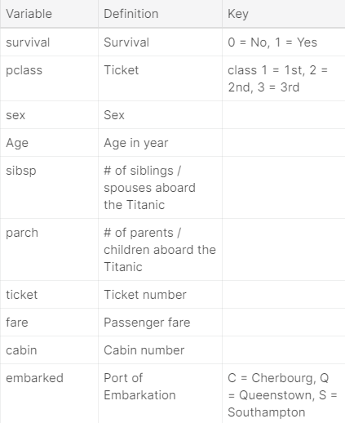

Test.csv first 6 row.

I will provide test.csv and train.csv full file

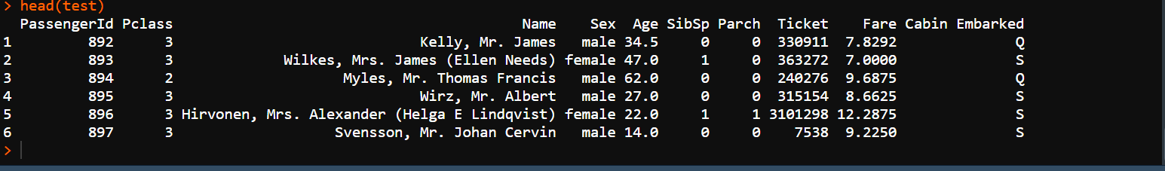

Train.csv

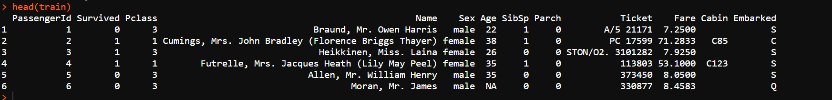

## Exploratory Data Analysis

## Missing Values

The first step is to find any and all missing data in the train and test sets.

**Missing values can be treated using following methods**

**1.Deletion**

**2. Mean/ Mode/ Median Imputation (which I follow in this session)**

Mean / Mode / Median imputation is one of the most frequently used methods. It consists of replacing the missing data for a given attribute by the mean or median (quantitative attribute) or mode (qualitative attribute) of all known values of that variable.

**3. Prediction Model**: Prediction model is one of the sophisticated method for handling missing data. Here, we create a predictive model to estimate values that will substitute the missing data. In this case, we divide our data set into two sets: One set with no missing values for the variable and another one with missing values. First data set become training data set of the model while second data set with missing values is test data set and va`riable with missing values is treated as target variable. Next, we create a model to predict target variable based on other attributes of the training data set and populate missing values of test data set.We can use regression, ANOVA, Logistic regression and various modeling technique to perform this. But this method has some drawbacks.

#### Train Dataset

The test.csv dataset also had 3 columns with missing values: Age, Fare, and Cabin. Like the train dataset, the Cabin variable is sparse, with over 78% subjects missing values. The Age variable is populated for over 79% of the train subjects, and likely has good predictive power so it will likely be beneficial to impute values for subjects missing Age. The Fare variable is missing for a single subject. While Fare may not be an obvious predictor for survival, the fact that the dataset is over 99% complete for this variable indicates that it is a good candidate for imputation.

I can’t taking care of missing data which value is string which i can that is bellow(Rscript).

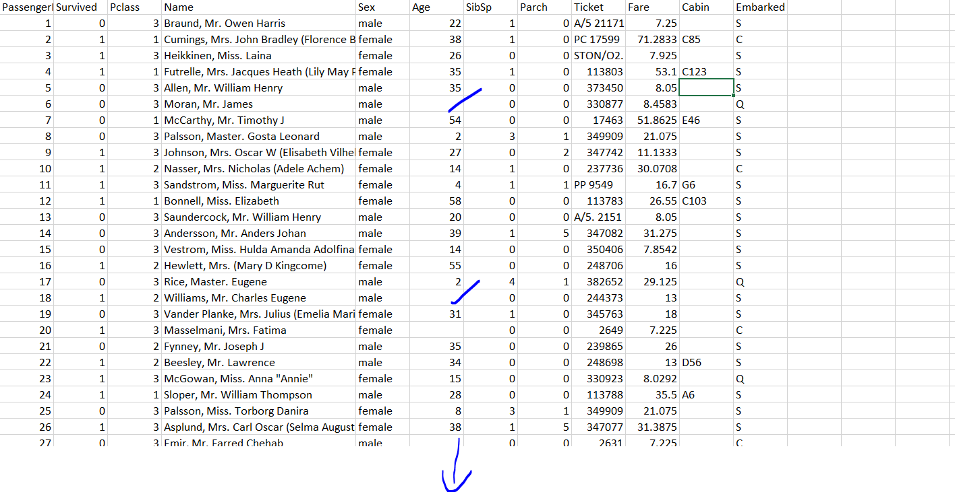

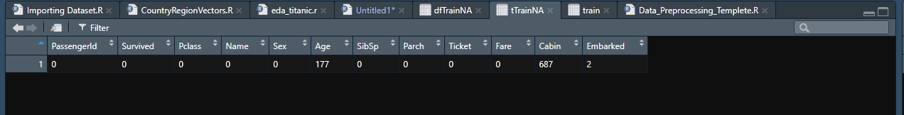

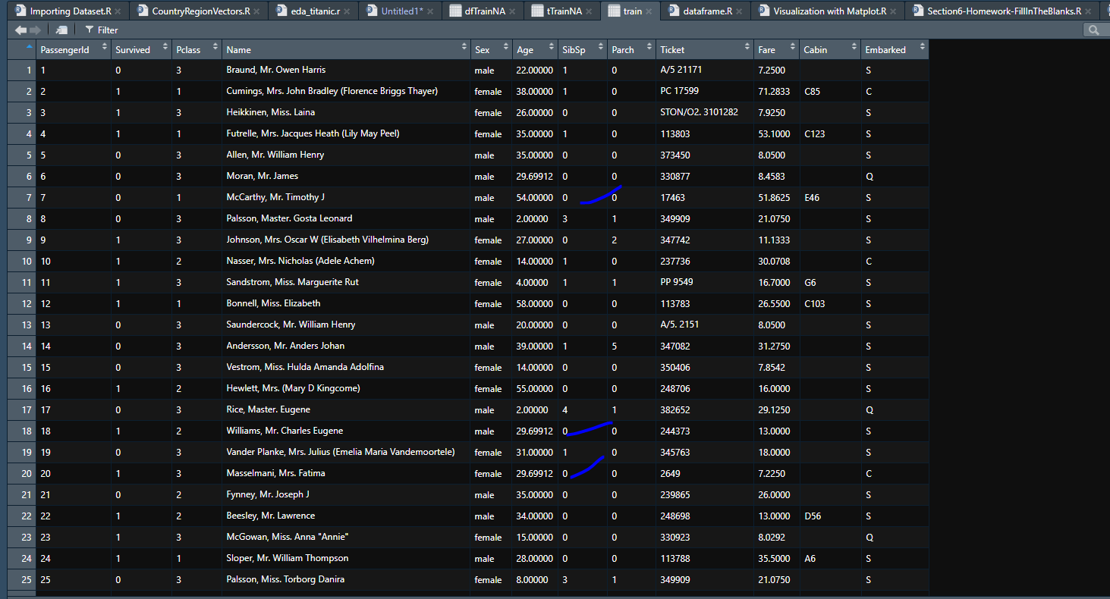

### Variable Features

#### PassengerId

PassengerId is a primary key for each row of data in the train and test sets. This variable will not be included in any of the predictive models.

#### Survived

Survived is the class we’re trying to predict.

#### Pclass

Passenger class is either 1st, 2nd, or 3rd.

N.B:In the upper marked there is an Export option to save your plot.But I don’t ,because I am lazy.i do it my practice session.

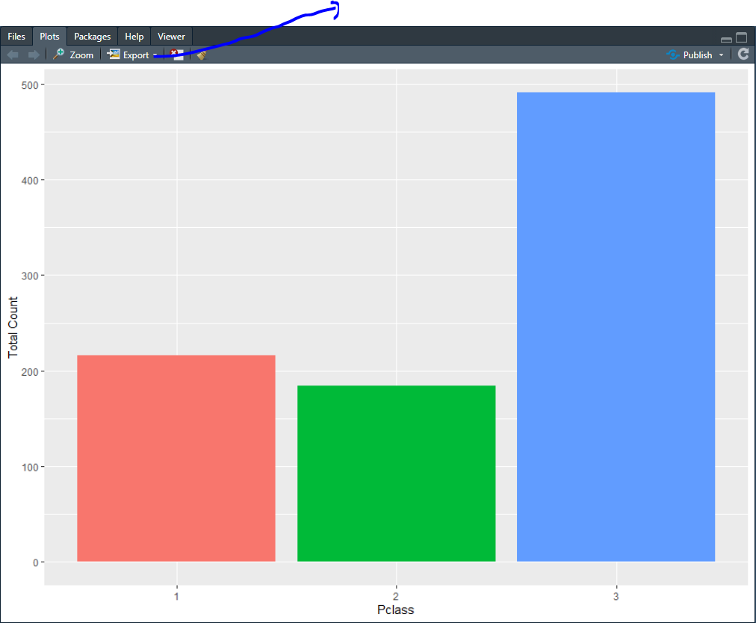

The Pclass variable shows that most passengers in the train set held a 3rd class ticket. 491 of the 891 passengers were 3rd class, more than 1st and 2nd class combined.

If the Survived variable is plotted as a function of passenger class, it appears that Pclass will be a predictor for survivability. A higher percentage of first class passengers survived than died, contrary to the overall trend, whereas a far higher percentage of 3rd class passengers died than survived.(for 2nd plot)

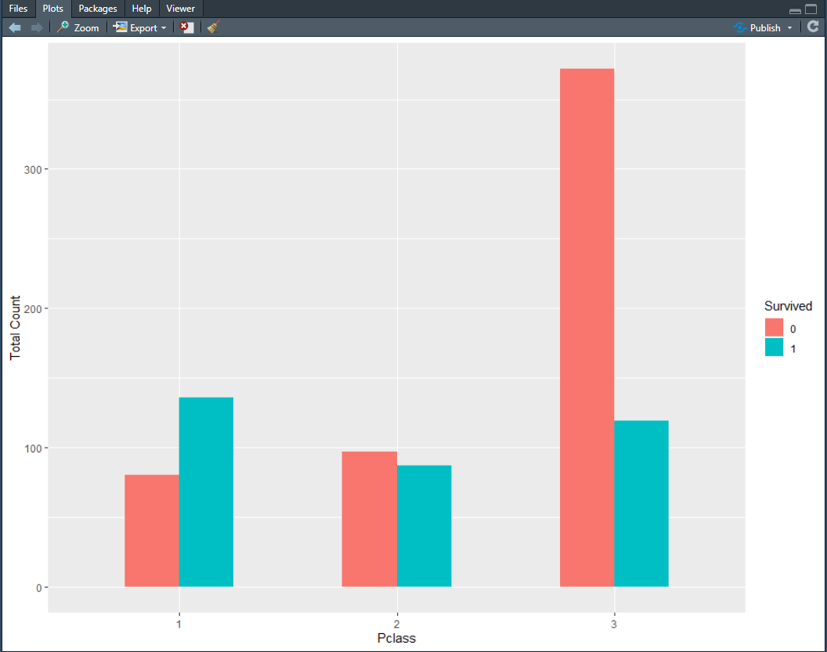

#### Name

It may seem that the passenger name is a lot like the PassengerId in that each name acts as a sort of primary key into the data and using name as a model feature would not generalize well. However, the name field could possibly provide value. The first twenty names in the train dataset:



Each name begins with a surname before a comma and a title. If the passenger is a married woman, her maiden name appears in parentheses. Some of the titles may help infer age (Master. and Miss.) and surnames could help determine extended family travelling together, even if they’ve purchased separate tickets and are not in the same cabin. Additionally, the presence of diacritical marks in a name could indicate that the passenger is a non-English speaker who might have had difficulty understanding instructions or the gravity of the situation.

#### **Sex**

Sex is an unordered factor, male or female.

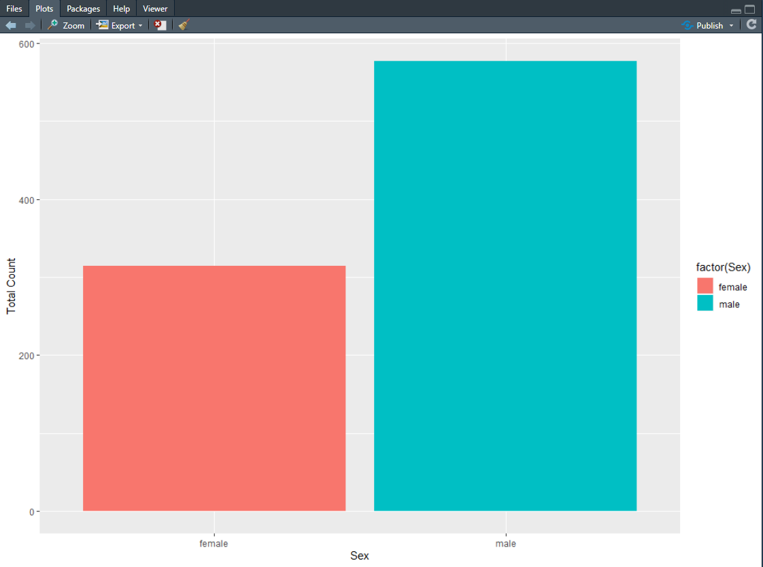

The Sex variable shows that most passengers in the training set were male (nearly 2/3 male). 577 of the 891 passengers were male, or 65%.

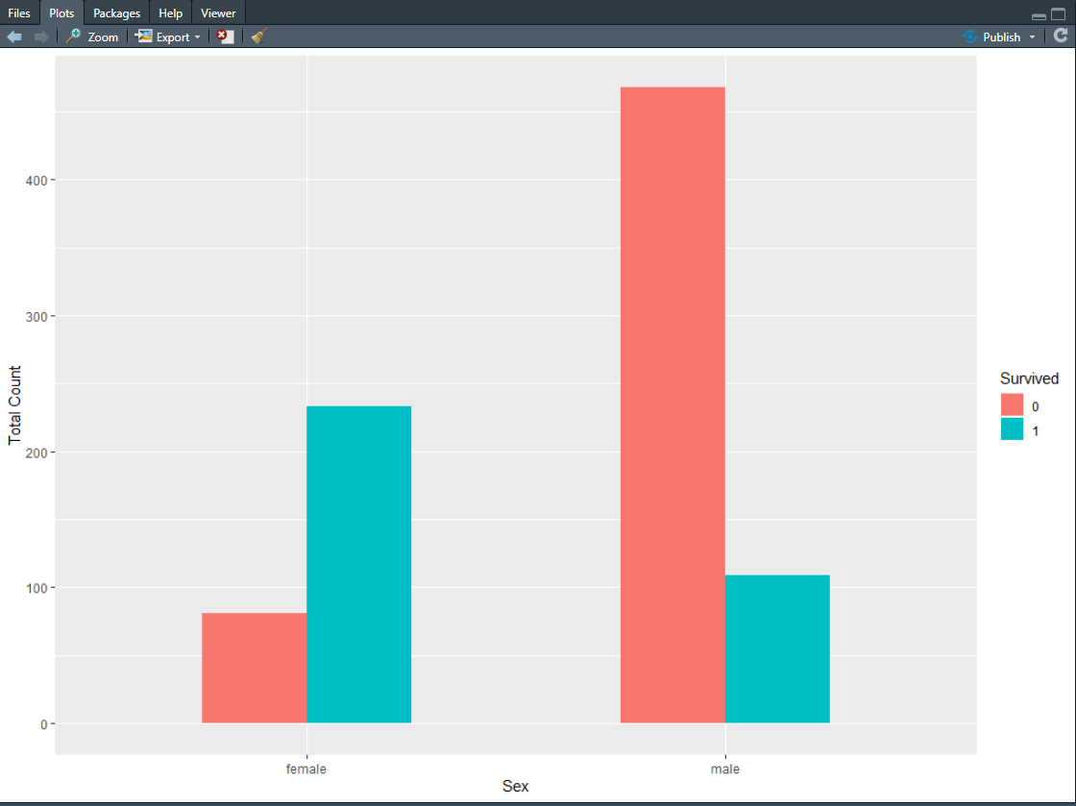

plotted as a function of Sex, it appears that Sex will be a strong predictor for survivability. Of the 314 female passengers in the training set, 233, or 74% survived. On the other hand, of the 577 male passengers, only 109 survived, or 19%.

#### **Age**

there are age values for 80% of the training subjects, missing for 177 passengers. The distribution of ages is slightly skewed right, with a median of 28 years and a mean of 29.7 years.

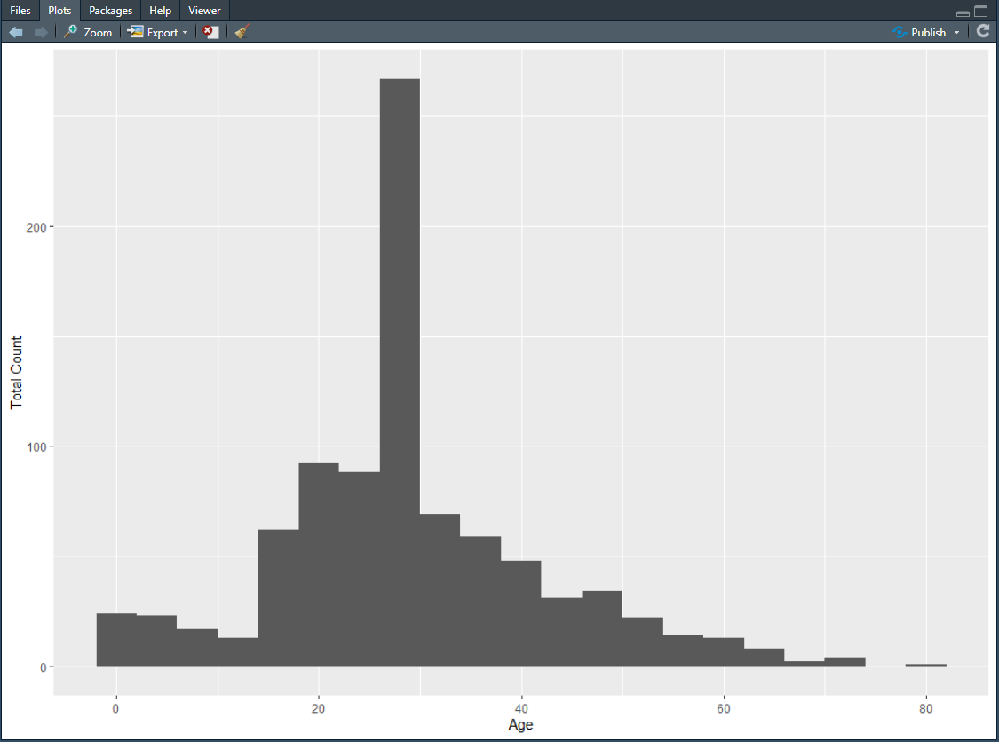

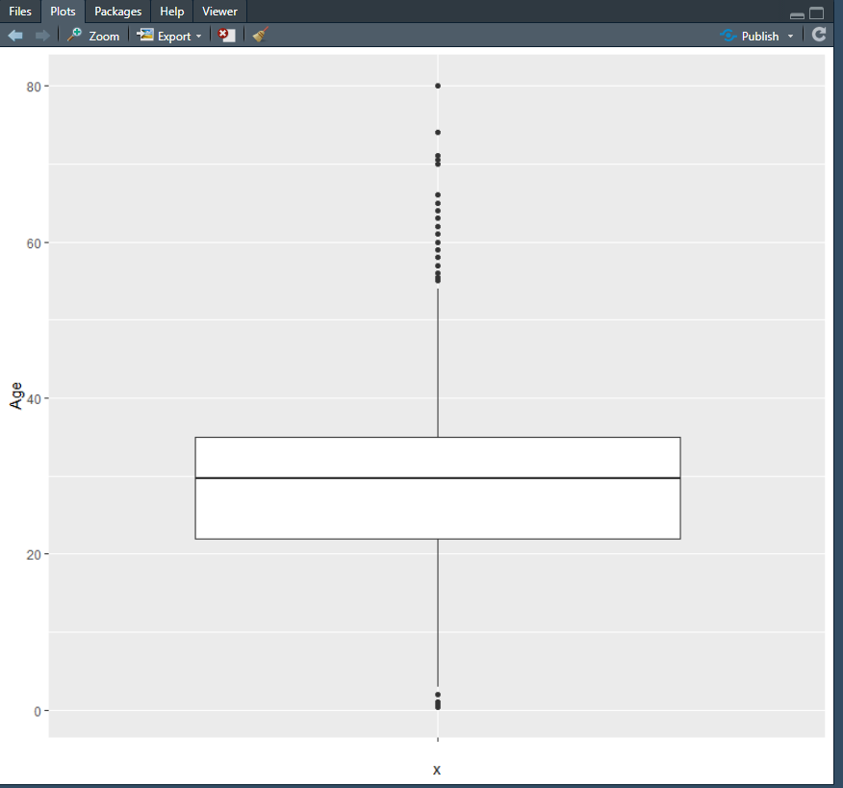

Age as a predictor of survivability

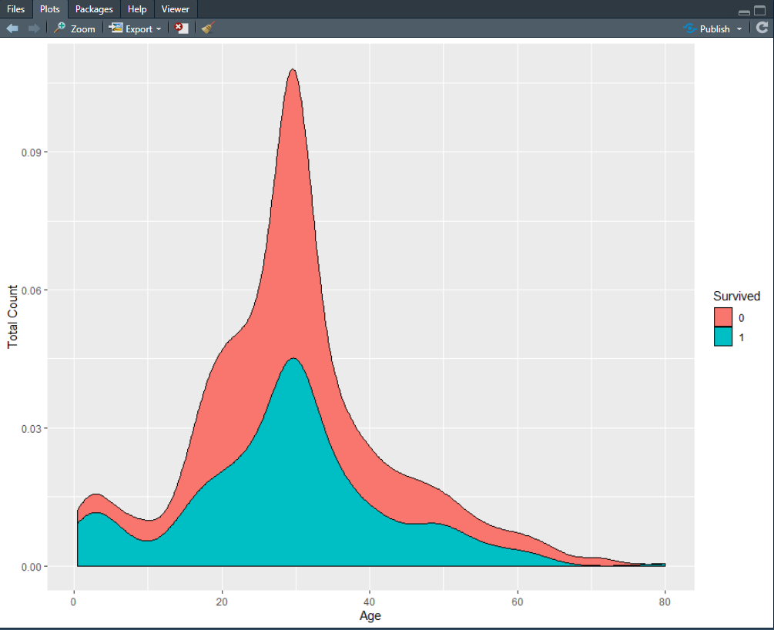

If we plot the Survived value as a function of the Age density, we see that there is a higher likelihood of younger passengers surviving over older passengers. Up until the mid-to-late teens, a training set passenger is more likely to survive than die, so age is likely to be a useful predictor for survivability.

#### **SibSp**

This variable is unique in that it is combination of number of siblings or “1” if the passenger had a spouse on board the ship. In some cases, it is not clear what the SibSp variable is encoding when a “1” is found - is the passenger travelling with a sibling or a spouse? A SibSp of 2 or more is indicative of siblings. It will likely be beneficial to disambiguate this variable into separate ‘Siblings’ and ‘Spouses’ variables.

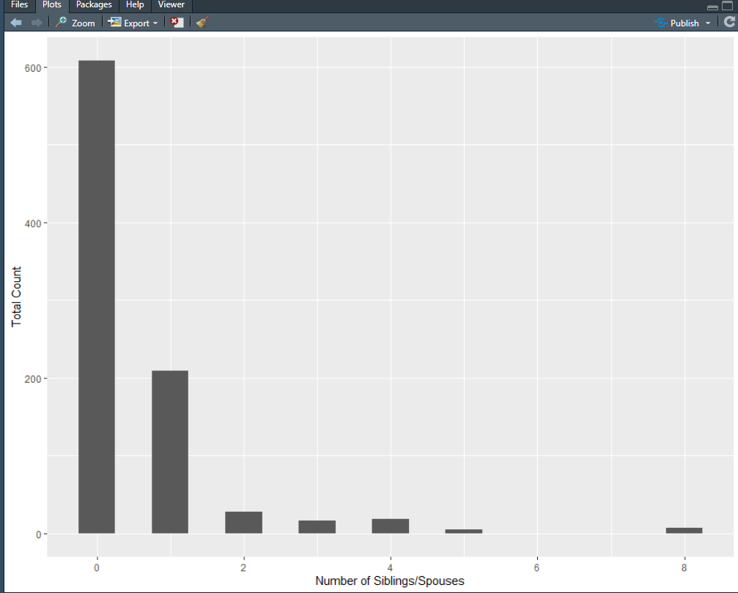

Most passengers in the training set (68%) had neither a spouse or sibling on board. 23% of the training set passengers had a single sibling or spouse on board. The remaining 9% of the passengers had two or more (presumably) siblings on board.

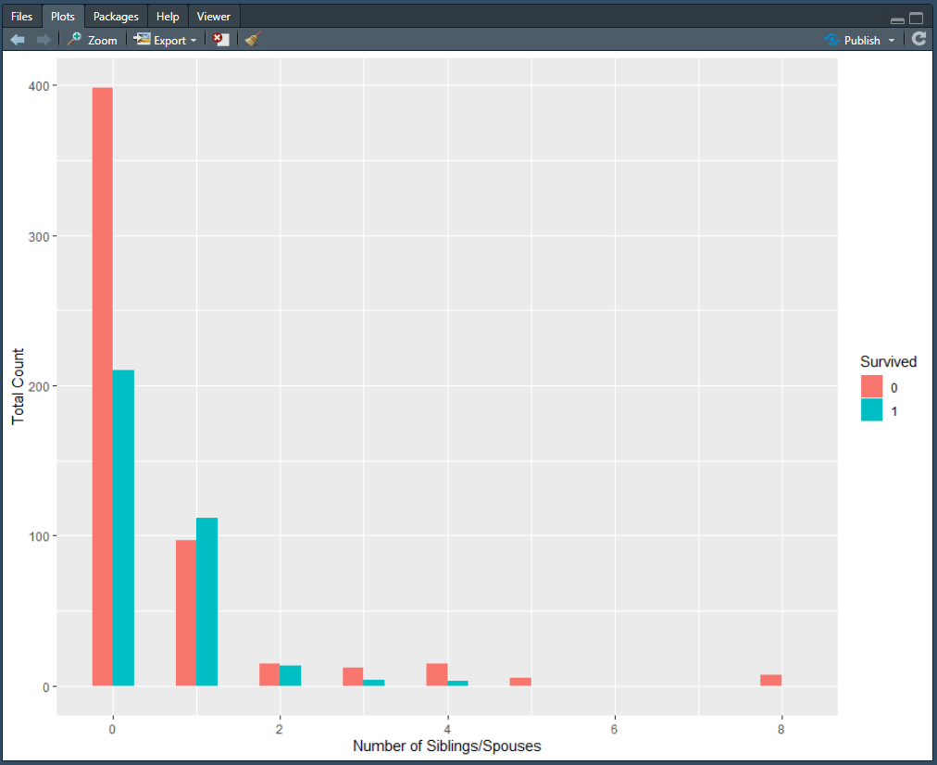

Survivability does appear to trend with the number of siblings/spouses on board. A passenger having no siblings or spouses is most likely to have died, whereas a passenger with one or two siblings/spouses has around a 50% likelihood of surviving. The remaining cases of three to eight siblings are likely too few from which to draw inferences individually, so it might make sense to pool the SibSp values as follows: 0, 1, 2, 3> to avoid overfitting to specific training cases. A close examination of the seven instances of the SibSp variable in which SibSp equals 8 reveals that all the subjects were from the same family and were in the same cabin. Predicting that all families of size 8 will perish is unlikley to generalize well.

#### **Parch**

Similar to SibSp, this variable convolves two separate pieces of data: the number of parents and the number of children this passenger has on board. In some cases, it is not clear what the Parch variable is encoding when a “1” is found - is the passenger travelling with a parent or a child? This can be inferred if the Age variable is present for the passenger, but if the Age is missing, it will be ambiguous and may need further analysis. Perhaps the passenger’s title (Mr., Miss., Master) could help. Like SibSp, it will likely be beneficial to disambiguate this variable into separate ‘Parents’ and ‘Children’ variables.

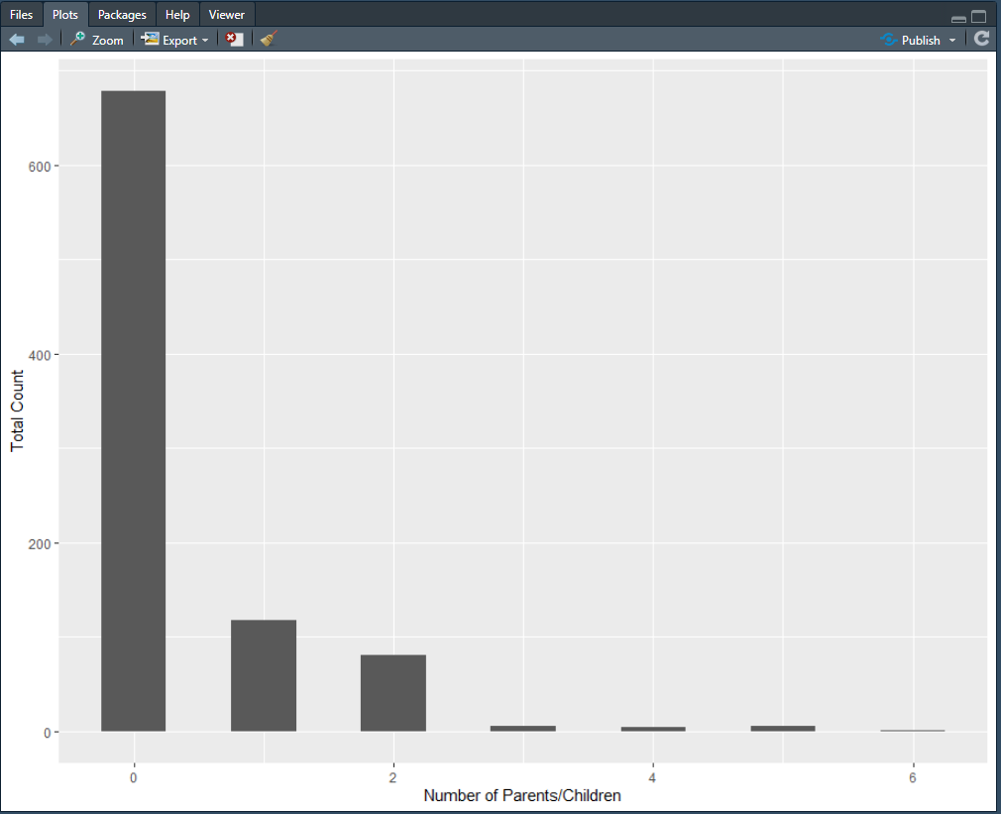

Most passengers in the training set (76%) had neither a parent or child on board. 13% of the training set passengers had a single parent or child on board. About 9% of the passengers in the training set (80) had two or more parents or children on board. The remaining 2% of the passengers had either 3, 4, 5, or 6 (presumably) children on board.

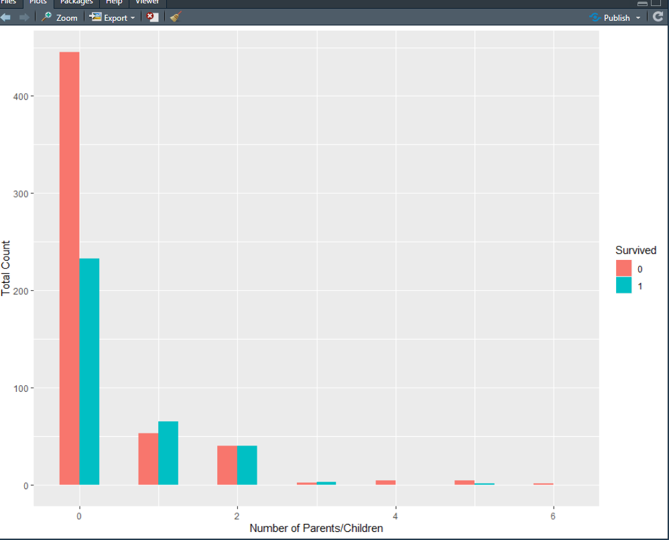

Survivability does appear to trend with the number of parents/children on board. A passenger having no parents or children is most likely to have died, whereas a passenger with one or two parents/children has around a 50% likelihood of surviving. The remaining cases of three to six children are likely too few from which to draw inferences individually, so it might make sense to group the Parch values as follows: 0, 1, 2, 3>= to avoid overfitting to specific training cases.

#### **Ticket**

The entries in the Ticket column do not seem to be of a uniform format. Some ticket entries are just numbers - ranging from 693-392096. Other ticket entries have character prefixes like “C.A.” or “SOTON/O2”, followed by a (presumably) ticket number.



An inspection of the set of tickets shows that presumed families tend to share a single ticket number. The first impression is that the ticket number seems an unlikely predictor for survivability and could lead to overfitting the training set. However, the ticket number might help populate the missing Cabin information - and Cabin might be a good predictor for survivability.

#### **Fare**

The fare (price paid per ticket) ranges from 0 to 512.3292. The units are unclear, but are likely in English pounds. The distribution is skewed to the right, with a median of 14.4542 and a mean of 32.20421. A log transform of the data may be necessary to normalize the distribution of fares. However, first the fare for passenger must be determined. It appears to be the case that individual ticket numbers are not assigned per passenger, but rather a single ticket number is given to the purchaser of an allotment of tickets. That is, families travelling together seem to be under the same ticket with the same fare. So, it may be necessary to get to create an “Amount Paid per Passenger” feature that takes into account the number of people for which a fare was purchased on a single ticket.

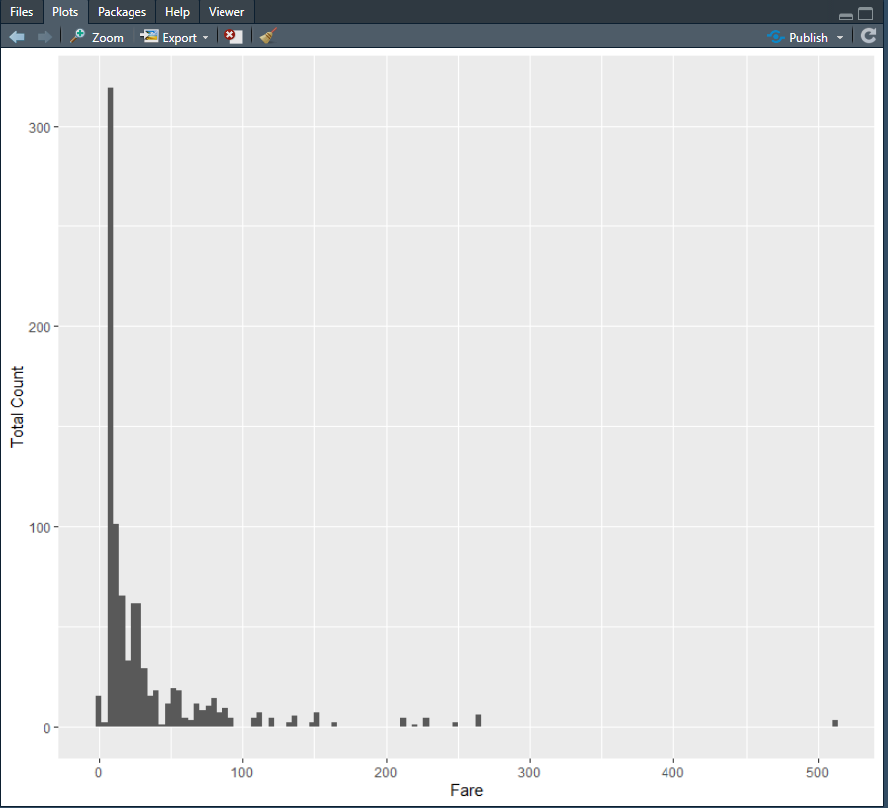

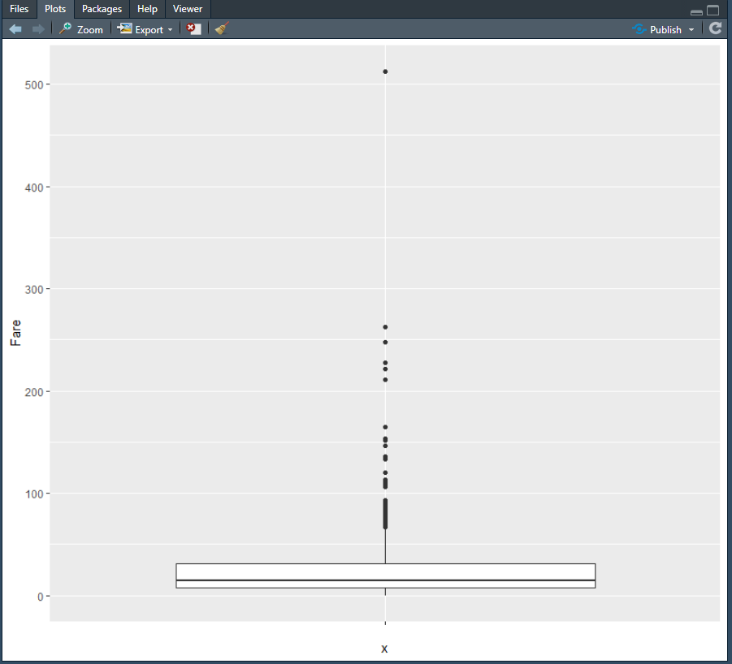

Fare could conceivably be an important factor in determining survivability. Perhaps the higher paying passengers received the first opportunity to board lifeboats. Or perhaps, those higher paying passengers were more initially unwilling to leave their more comfortable accomodations for the plebian conditions aboard a lifeboat. Fare as a predictor of survivability:

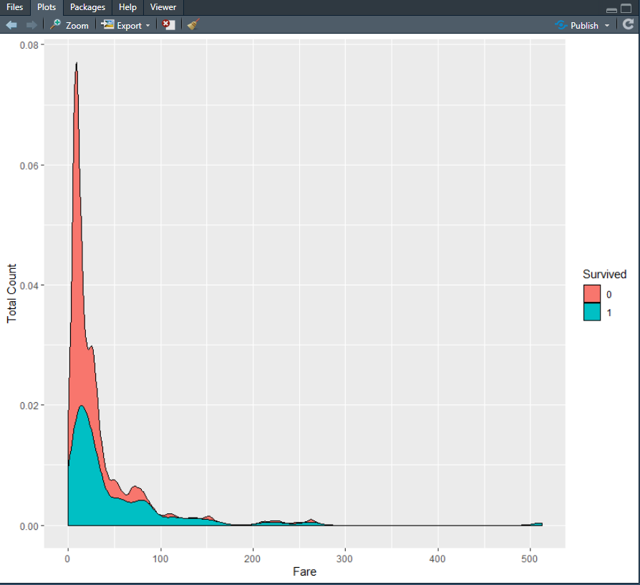

#### **Cabin**

The Cabin feature could be another strong predictor for survivability. Perhaps cabins located nearest the lifeboats afforded the best survivability. But, the Cabin variable has many empty values. The empty values could mean that the information was not captured or it could mean that not all passengers received cabins and stayed in other accomodations. Being assigned a cabin could be a proxy for one’s social status and wealth. If so, the Pclass variable might be co-linear.

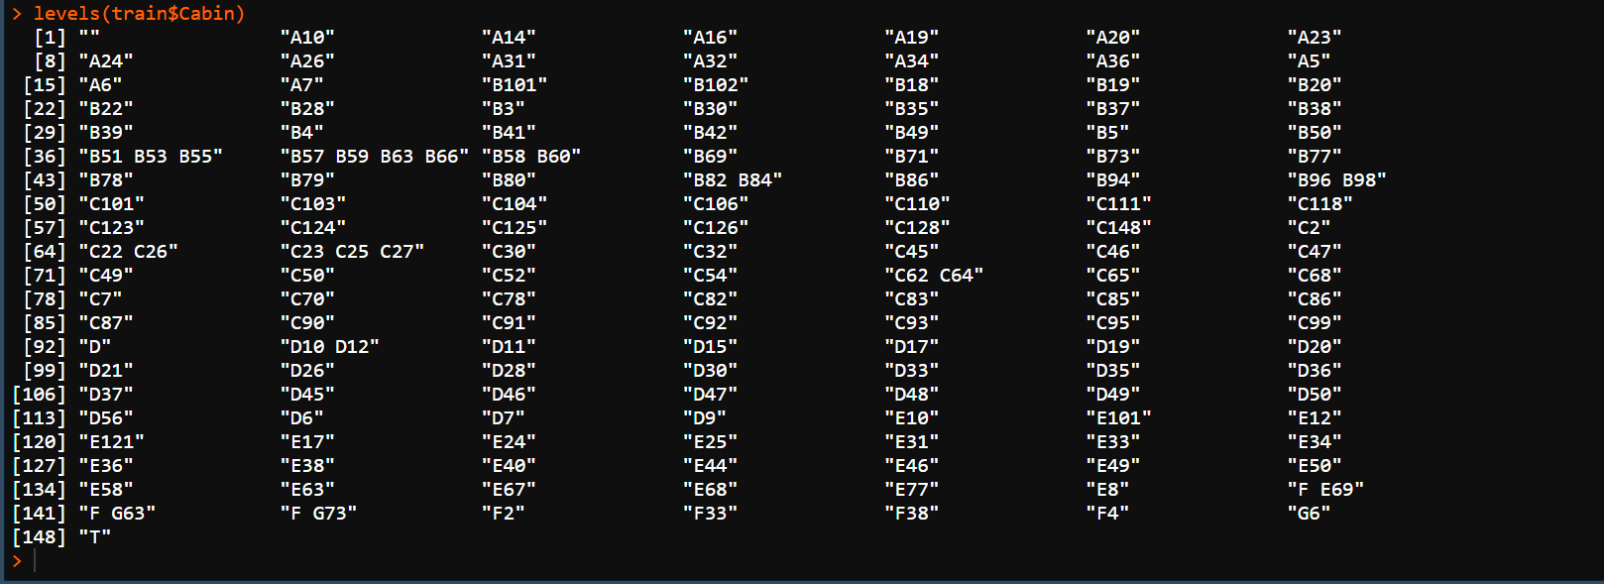

The cabin name mostly adheres to the rule of a single letter A-F,G,T, followed by a number up to 3 digits. There are cases where a passenger has multiple cabins, each separated by whitespace. The beginning letter of each cabin could denote a deck or particular region of the ship - which could help with predicting survivability. Alternatively, the number of the cabin could be more informative than the beginning letter. Perhaps cabins “A19” and “B19” are located right next to one another, for instance.

Some Resources(link)

1. <https://www.udemy.com/course/r-programming/?utm_source=adwords&utm_medium=udemyads&utm_campaign=DataScience_v.PROF_la.EN_cc.ROW_ti.5336&utm_content=deal4584&utm_term=_._ag_85469003754_._ad_395279056262_._kw__._de_c_._dm__._pl__._ti_dsa-774930027489_._li_9069458_._pd__._&matchtype=b&gclid=Cj0KCQiAwP3yBRCkARIsAABGiPp4MNAsWWATgBm1oXYACbH_KduSTnCjz6m28QEACJDXC1ZgcjUQ9WEaAmOEEALw_wcB> Basically I complete this course. If anyone wanna this course ,I will provide.In this course actually “Advanced Visualization” part more details ggplot and other part also describe metaplot. You can say that it’s a course which is best for neophytes of Learning R programing.
2. <https://www.udemy.com/course/machinelearning/> From this course I complete the “Data preprocessing part”.

**3**.Issing value related [https://medium.com/coinmonks/dealing-with-missing-da ta-using-r-3ae428da2d17](https://medium.com/coinmonks/dealing-with-missing-da%20%20%20%20%20%20ta-using-r-3ae428da2d17)

**4.**kaggle.com

N.B:I also help from internet , but I do it fully manually.